**439 stolen cars seized in 12 days as part of Frontex-led operation**

2019-10-14

439 stolen cars, 11.9 million illegal cigarettes and 20 tonnes of raw tobacco were recovered in a 12-day operation led by Frontex, the European Border and Coast Guard Agency, in late September and early October.  
  
The operation, known as Joint Action Day (JAD) Mobile 2, targeted serious and organised cross-border crime across Europe. It focused on the detection of stolen cars and car parts, smuggling of migrants and related document fraud. Germany, Greece, the Netherlands, Poland and Europol co-led the operation.   
  
Within less than two weeks, the international cooperation led to:

* detection of 439 stolen cars and 230 stolen parts
* arrest of 166 suspected people smugglers, drugs smugglers  and those for the possession of smuggled excise goods and weapons
* detection of 183 fraudulent documents
* seizure of 11.9 million cigarettes and 20 tonnes of raw tobacco
* seizure of 38 firearms and 296 pieces of ammunition
* seizure of 83.5 kg hashish, 82.6 kg marijuana, and 29.5 kg of cocaine

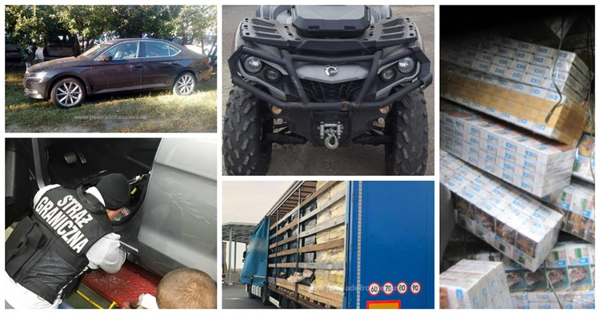

Among the stolen car parts were 164 car engines tracked down by Greek authorities after a year-long investigation.  
  
The operation also led to the detection of 4 365 irregular migrants.  
  
In total, 13 EU and five non-EU countries took part in the operation. EU agencies and international organisations, such as Europol and Interpol, assisted in real-time operational information exchange between the participants.   
Frontex hosted a coordination centre for the operation at its headquarters in Warsaw.   
  
The operation was coordinated under the umbrella of the European Multidisciplinary Platform against Criminal Threats (EMPACT) as part of the EU Policy Cycle, a four-year plan for the fight against serious and organised crime. It brings together police and law enforcement authorities of EU Member States, European agencies and international organisations to jointly strengthen Europe’s borders and internal security. The results and intelligence gathered will help in ongoing and future investigations.